Partner Toolkit:
Rapid Adoption of Telehealth by Primary Care Clinicians in Southeastern U.S. States During the COVID-19 Pandemic

Report Released by Morehouse School of Medicine’s
National Center for Primary Care

Researchers at Morehouse School of Medicine’s (MSM’s) National Center for Primary Care (NCPC), in partnership with the United Health Foundation (UHF) have released Rapid Adoption of Telehealth by Primary Care Clinicians in Southeastern U.S. States During the COVID-19 Pandemic. This pressing report highlights findings from the Digital Health Tools Study (DHTS) around the adoption and use of digital health tools, such as telehealth, by more than 1,200 primary care clinicians practicing in underserved communities in four Southeastern states: Georgia, Kentucky, North Carolina, and Tennessee.

You can find the report on the National Center for Primary Care’s website under the “Reports” section: https://www.msm.edu/Research/research_centersandinstitutes/NCPC/DigitalTechnologySurvey/index.php.

Shortened link: bit.ly/DHTstudy (this link is case-sensitive)

This toolkit is intended to serve as a resource so that you can share this report broadly. Please reach out to Mitchell A. Blount, MPH (mblount@msm.edu) if you have any questions.

Key Social Media Handles:
 | National Center for Primary Care | Morehouse School of Medicine
Twitter | @MSM_NCPC  @NCPC_Policy | @MSMEDU
Facebook | @MSMNCPC | @MorehouseSchoolofMedicine
LinkedIn | Morehouse School of Medicine National Center for Primary Care | Morehouse School of Medicine
Instagram |  | @morehouseschoolofmedicine

Suggested Tweets:
- Our friends @MSM_NCPC from @MSMEDU just released an important report highlighting the use of telehealth in primary care settings in the Southeast US. Learn more about their findings here: bit.ly/DHTstudy
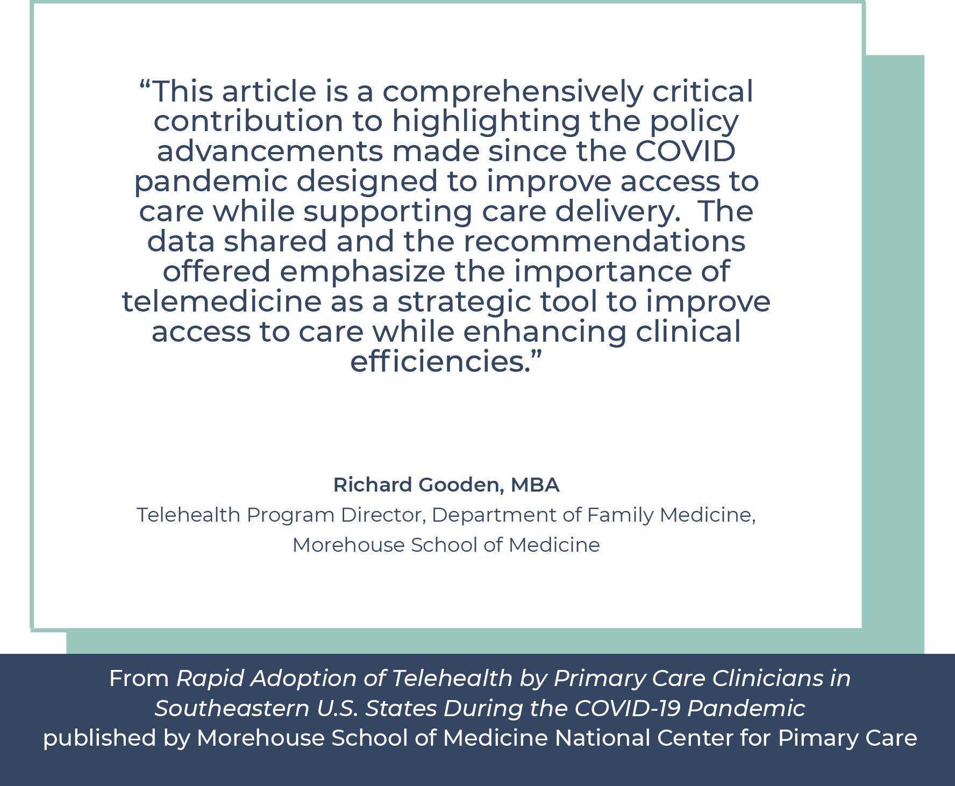
Alt text: quote from Richard Gooden, Telehealth Program Director at the Department of Family Medicine at the Morehouse School of Medicine: “This article is a comprehensively critical contribution to highlighting the policy advancements made since the COVID pandemic designed to improve access to care while supporting care delivery. The data shared and the recommendations offered emphasize the importance of telemedicine as a strategic tool to improve access to care while enhancing clinical efficiencies.”
- Our friends @MSM_NCPC from @MSMEDU just released an important report highlighting the use of telehealth in primary care settings in the Southeast US. Learn more about their findings here: bit.ly/DHTstudy

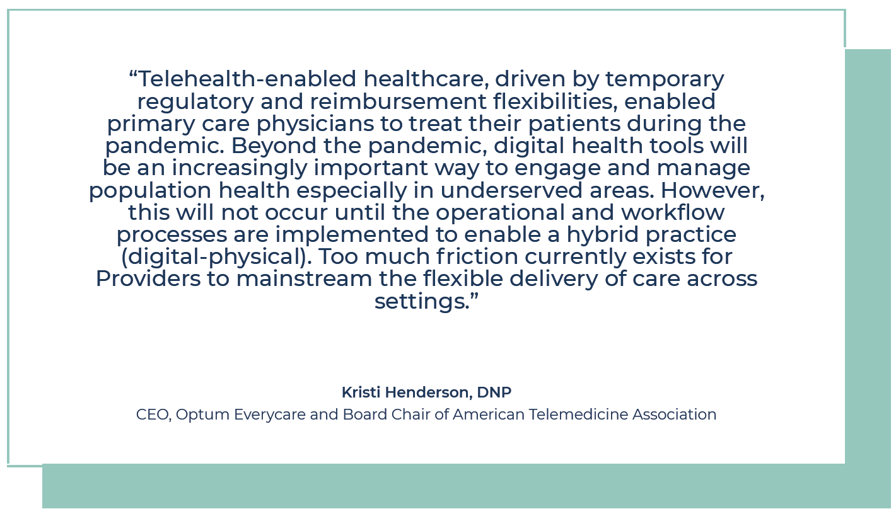
Alt text: quote from Dr. Kristi Henderson, CEO at Optum Everycare and Board Chair of the American Telemedicine Association: “This article is a comprehensively critical contribution to highlighting the policy advancements made since the COVID pandemic designed to improve access to care while supporting care delivery. The data shared and the recommendations offered emphasize the importance of telemedicine as a strategic tool to improve access to care while enhancing clinical efficiencies.”

- Our friends @MSM_NCPC from @MSMEDU just released an important report highlighting the use of telehealth in primary care settings in the Southeast US. Learn more about their findings here: bit.ly/DHTstudy

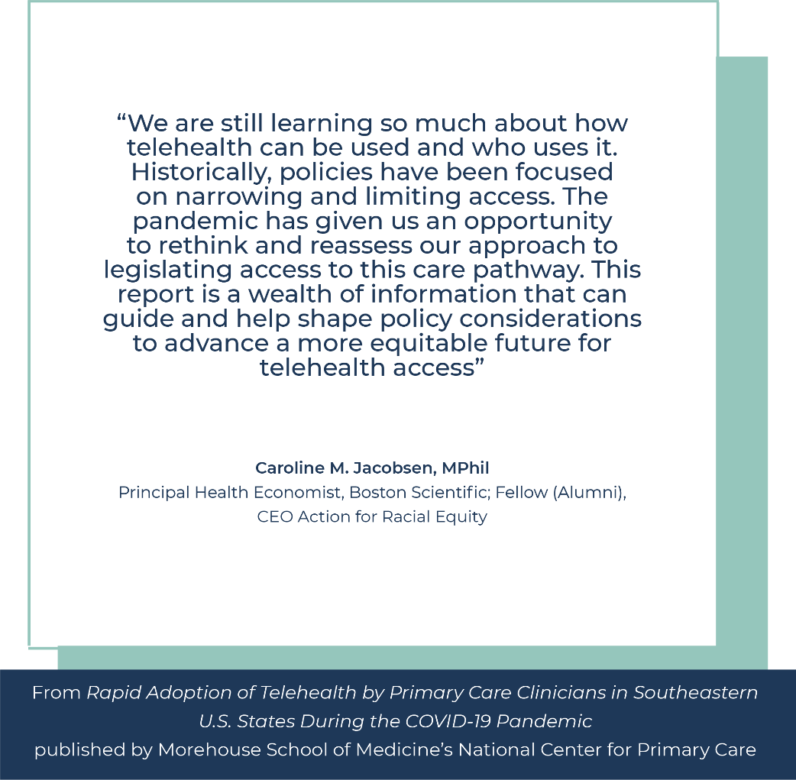
Alt text: quote from Caroline M. Jacobsen, Principal Health Economist at Boston Scientific and CEO at Action for Racial Equity: “Telehealth-enabled healthcare, driven by temporary regulatory and reimbursement flexibilities, enabled primary care physicians to treat their patients during the pandemic. Beyond the pandemic, digital health tools will be an increasingly important way to engage and manage population health especially in underserved areas. However, this will not occur until the operational and workflow processes are implemented to enable a hybrid practice (digitalphysical). Too much friction currently exists for Providers to mainstream the flexible delivery of care across settings.”

- We are excited to see @MSM_NCPC release their report on how primary care settings used telehealth during the #COVID19 public health emergency. This report highlights important shifts in policy that made telehealth easier to access and use. More info: bit.ly/DHTstudy
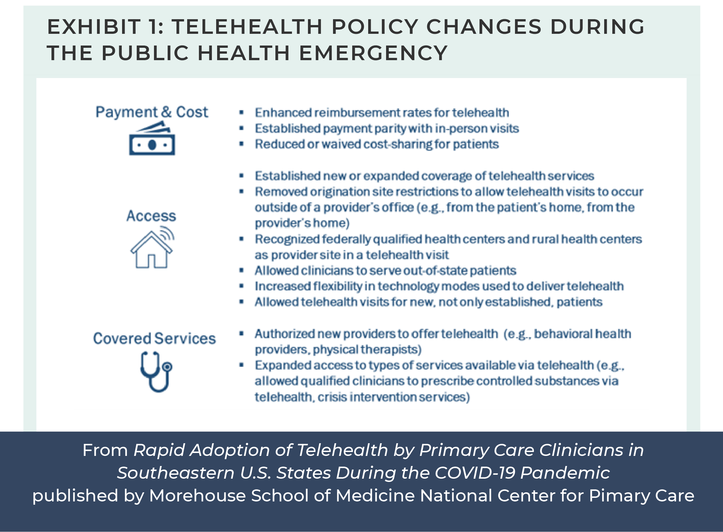
Alt text: Exhibit 1: Telehealth policy changes during the public health emergency: payment and cost, access, covered services.

- Our partners at @MSM_NCPC have released a new report describing the rapid adoption of telehealth by primary care clinicians in the Southeastern US. This work was part of a larger Digital Health Tools Study in partnership with United Health Foundation. More info: bit.ly/DHTstudy

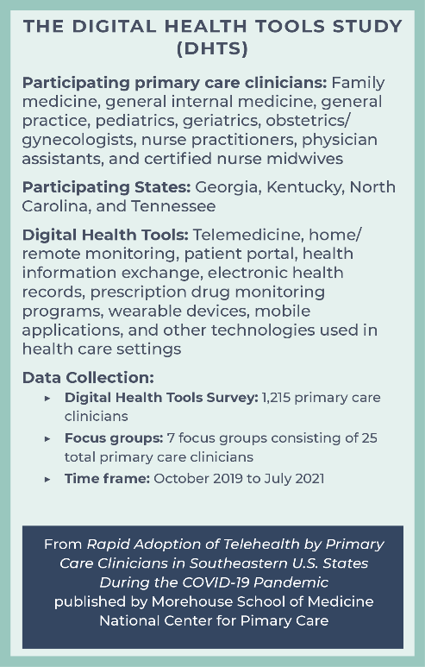
Alt text: The Digital Health Tools Study (DHTS): Participating primary care clinicians: Family medicine, general internal medicine, general practice, pediatrics, geriatrics, obstetrics/gynecologists, nurse practitioners, physician assistants, and certified nurse midwives. Participating States: Georgia, Kentucky, North Carolina, and Tennessee.
Digital Health Tools: Telemedicine, home/remote monitoring, patient portal, health information exchange, electronic health records, prescription drug monitoring programs, wearable devices, mobile applications, and other technologies used in health care settings. Data Collection: Digital Health Tools Survey: 1,215 primary care clinicians.
Focus groups: 7 focus groups consisting of 25 total primary care clinicians.
Time frame: October 2019 to July 2021
Sample Newsletter Entry:

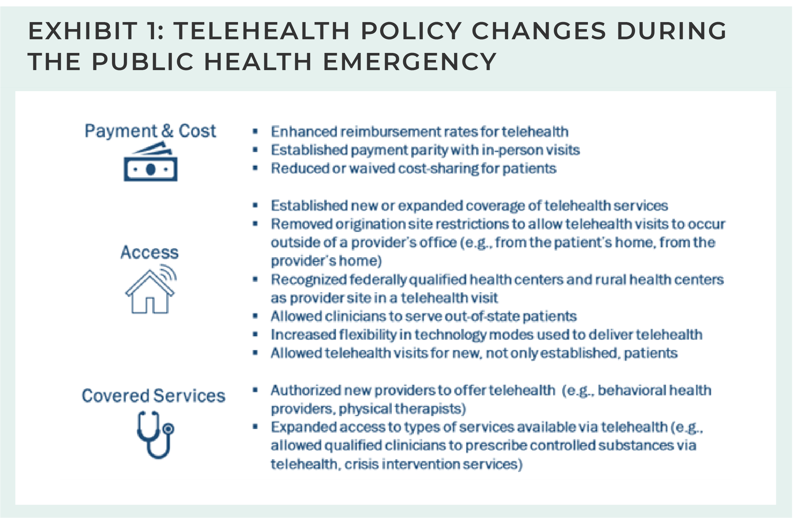

Morehouse School of Medicine’s National Center for Primary Care, in partnership with the United Health Foundation, recently released a key report: Rapid Adoption of Telehealth by Primary Care Clinicians in Southeastern U.S. States During the COVID-19 Pandemic. This pressing report highlights findings from the Digital Health Tools Study (DHTS) around the adoption and use of digital health tools, such as telehealth, by more than 1,200 primary care clinicians practicing in underserved communities in four Southeastern states: Georgia, Kentucky, North Carolina, and Tennessee. It suggests several policy and practice changes are needed beyond the COVID-19 public health emergency to sustain and maximize telehealth opportunities moving forward:
- Nationwide expansion of telephone and audio-only telehealth services
- Continued expansion of the originating site and geographic locations
- Investments in broadband and telecommunications infrastructure, particularly in underserved and rural communities and for smaller and less-resourced practices
- Telehealth services and payment parity with in-person services

Additional Resources:
If you’d like to learn more about the National Center for Primary Care and its divisions, please visit: https://www.msm.edu/Research/research_centersandinstitutes/NCPC/index.php

