**Priming for Efficient Patient Encounters**

**Just like *priming a pump*, taking 1 minute to “PRIME” your learners prior to each patient encounter will improve efficiency and effectiveness of your teaching and patient encounters!**

**Priming involves 3 P’s:**

**PREPARE with your learner at start of session; PRIME before each patient interaction; PLAN next steps.**

1

**PREPARE with your learner from “Well” of Patient Encounters**

**Scan Clinic Schedule: Look for urgent/must be addressed patient issues; schedule length; learner friendly patients**

**Check Learner Needs/Gaps: Rotation/training requirements – learner’s gaps = today’s focus (e.g., chronic disease; prevention; communication)**

**Rescan Schedule: Match patients with learner needs and clinic flow**

PREPARE 3-5 min

# 3

1

min

1

**2** min

1

min

1

min

1

min

# 1

**2**

**High Quality, Efficient Patient Care & Learning**

**PRIME for EACH patient by telling the learner in < 1 minute:**

**Who is the Patient: 56 y/o patient; Type 2 DM; Here for 3 month follow up; DM is uncontrolled**

**What to Do & Time: Assess barriers to control DM; Consider Motivational Interviewing; 10 minutes**

**Why Do it: Chronic Disease management requires patient commitment & engagement**

**What You Expect: 2 minute summary of top 2 actionable barriers patient agrees to work on**

PRIME 1 min

3

**PLAN what you and/or learner will do when go back in to see patient following the learner’s 2-minute summary:**

**Patient Management: Agree on patient plan and timing for patient follow-up visit.**

**Clarify Roles when Re-enter Patient’s Room**

1. **PRECEPTOR WILL: Greet Patient; tell patient learner will review H&P, summarize barriers, and key focus area(s)**
2. **LEARNER WILL: Review H & P & barriers and recommend 1 actionable step (e.g., D/C canned fruit; switch to 1 fresh fruit/day). Rec patient schedule follow-up visit 3 mos**

PLAN 3 min

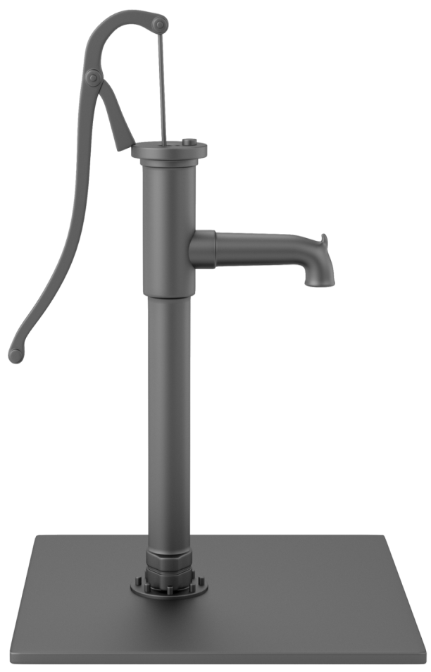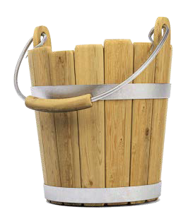

**Resources:**

* Heidenreich C, Lye P, Simpson D, Lourich M. The search for effective and efficient ambulatory teaching methods through the literature. Pediatrics. 2000;105(1);S231-237.
* Pettit J, Rosenbaum M. Strengthening Your Teaching Toolbox. MedEdPORTAL Publications; 2014. Available from: https://[www.mededportal.org/publication/9873](http://www.mededportal.org/publication/9873) [http://dx.doi.org/10.15766/mep_2374-8265.9873.](http://dx.doi.org/10.15766/mep_2374-8265.9873)

**Created by WISE FM:** Douglas Bower, MD, David Deci, MD, Maureen Longeway, MD, & Deborah Simpson, PhD with graphic support from Sharon Sabourin. Published July 2015 as part of WISE FM (Wisconsin Institute of Scholars & Educators in Family Medicine); a statewide faculty development collaborative affiliated with: